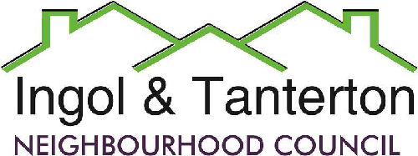

Gill Mason - Clerk and RFO

Email: [ingoltantertonnc@hotmail.co.uk](mailto:ingoltantertonnc@hotmail.co.uk)

**Agenda**

**A meeting of the Ingol and Tanterton Neighbourhood Council Area Enhancement Committee will be held on Thursday 27th February 2024 at 7pm at Tanterton Village Centre.**

**Open forum**

1.To receive apologies.

2.To approve the meeting held Wednesday 17th July 2024.

3.To consider the update on the shop ownership/lease.

4.To consider the maintenance to the Tanterton Village Green area.

Press and public are welcome to attend.

Press and public are welcome to attend.